Online Survey seeking comment for the 2021 review and update of the JORC Code released for public submissions

The Australasian Joint Ore Reserves Committee (JORC) has today released for public submission an online survey seeking comment ahead of the 2021 review and update of the JORC Code.

Submissions are open online at http://www.jorc.org/code-update.asp until 12th February 2021.

The survey is the next step of the review process and will be followed by a summary issues paper to be circulated at the end of April 2021. Further industry feedback will then be sought before finalisation of the updated code.

The JORC Chair , Steve Hunt has noted “We would normally have started the periodic review of the JORC code with public meetings of JORC stakeholders, though as with many things in 2020 this has not been possible due to the COVID pandemic impacts. The survey allows us to start receiving feedback from various stakeholders and to plan for more direct engagement in early 2021 as restrictions ease”.

The Code was last updated in 2012 and there are a number of areas where industry, regulator and public expectations have evolved since the last update. Importantly, the key focus of the Code remains to provide principles based disclosure transparency for investors and potential investors in the mining and exploration markets. The update survey is open to individuals, companies and other stakeholder groups to provide feedback on the JORC Code including their views on specific areas for review, improvement or alignment within the Code.

Yours sincerely
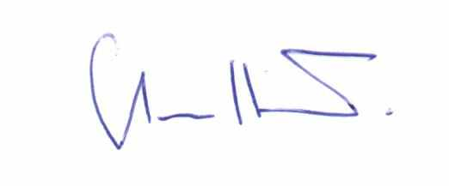
Steve Hunt
Chair, JORC Committee
4th December 2020

Background to the JORC code
The Australasian Code for Reporting of Exploration Results, Mineral Resources and Ore Reserves ('the JORC Code') is a professional code of practice that sets minimum standards for Public Reporting of minerals Exploration Results, Mineral Resources and Ore Reserves.
The JORC Code provides a mandatory system for the classification of minerals Exploration Results, Mineral Resources and Ore Reserves according to the levels of confidence in geological knowledge and technical and economic considerations in Public Reports.
Public Reports prepared in accordance with the JORC Code are reports prepared for the purpose of informing investors or potential investors and their advisors. They include, but are not limited to, annual and quarterly company reports, press releases, information memoranda, technical papers, website postings and public presentations of Exploration Results, Mineral Resources and Ore Reserves estimates.
The JORC Code was first published in 1989, with the most recent revision being published late in 2012. Since 1989 and 1992 respectively, it has been incorporated in the Listing Rules of the Australian Securities Exchange, other Australian stock exchanges and New Zealand Stock Exchange, making compliance mandatory for listing public companies in Australia and New Zealand.
Public reporting in accordance with the Code requires the formal signoff of a Competent Person, who is a mining professional meeting specific qualification, experience and professional membership requirements.

The JORC committee
The JORC Code is produced by the Australasian Joint Ore Reserves Committee ('the JORC Committee'). The JORC Committee was established in 1971 and is sponsored by the Australian mining industry and its professional organisations.
The JORC Committee comprises representatives of each of the three parent bodies: The Minerals Council of Australia (MCA), The Australasian Institute of Mining and Metallurgy (The AusIMM), and the Australian Institute of Geoscientists (AIG); as well as representatives of the Australian Securities Exchange (ASX), the Financial Services Institute of Australasia (FinSIA) and the accounting profession, and an observer from the Association of Mining and Exploration Companies (AMEC).
The JORC Committee is a member of and works closely with CRIRSCO, the Committee for Mineral Reserves International Reporting Standards to ensure international consistency in the development of reporting standards and the promotion of best practice in implementation of the relevant standards and codes.

